COSC 3P93
Introduction

Parallel Computing
- “They cannot see the forest for the trees” = Inability to grasp the main issue due to excessive attention to detail
- Can we first learn parallel programming w/out first knowing computer architecture?

Trees Forest
Cores Parallelism, Locality
H/W Threads Parallelism, Locality
Vectors Parallelism, Locality
Offload Parallelism, Locality
Heterogeneity Parallelism, Locality
Cloud Parallelism, Locality
Caches Parallelism, Locality
NUMA Parallelism, Locality
- We need to learn the forest:
  - Increase exposing parallelism
  - Increase locality of reference - "principle of locality" = the tendency of a processor to access the same memory locations repetitively over a short period of time
  - Why? Because its programming that addresses the universal needs of computers today and in the future

Serial Computing
- Traditionally, software has been written for serial computation
  - A problem is broken into a discrete series of instructions
  - Instructions are executed one at a time sequentially
  - Execution takes place on a single processor
  - Only one instruction my execute at any moment in time

Parallel Computing
- Parallel computing, in the simplest sense, is the simultaneous use of multiple computer resources to solve a computational problem
  - A problem is broken down into discrete parts that can be solved concurrently
  - Each part is further broken down into a series of instructions
  - Instructions from each part execute simultaneously on different processors
  - An overall control/coordination mechanism is employed

eg. Serial
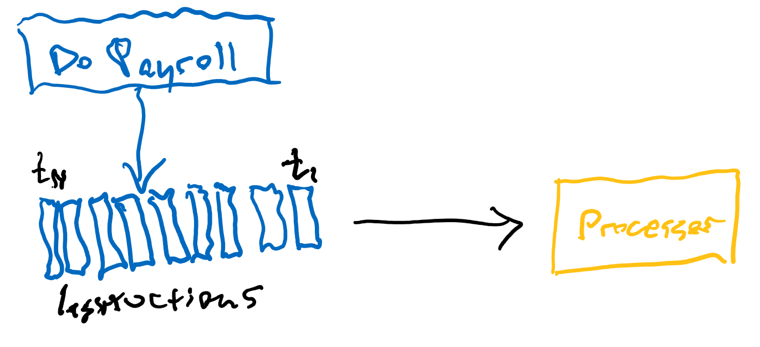
Eg. Parallel
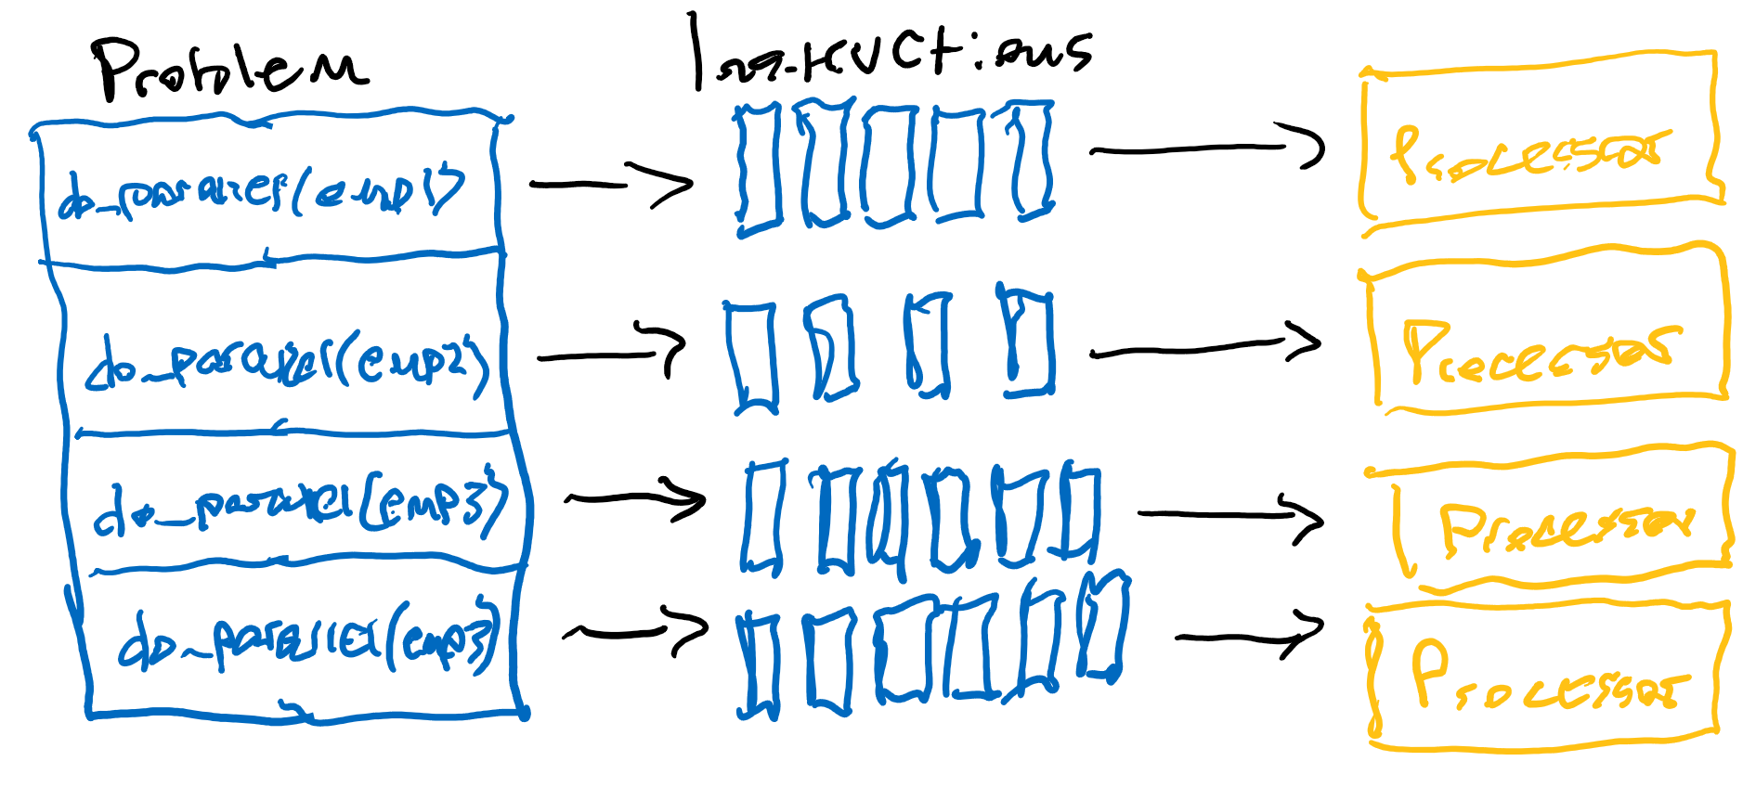
Considerations:
- The computational problem should be able to:
  - Be broken down into smaller discrete pieces of work that can be solved simultaneously
  - Execute multiple program instructions at any moment in time
  - Be solved in less time w/ multiple compute resources than with a single compute resource
- The compute resources are typically:
  - A single computer with multiple processors/cores
  - An arbitrary number of such computers connected by a network

Parallel Computers
- Virtually all stand-alone computers today are parallel from a hardware perspective
  - They have multiple functional units (L1/L2 cache, branch, prefetch, decode, floating-points, graphics processing, integer, etc…)
  - Multiple execution units/cores
  - Multiple h/w threads

Networking
- Networks connect multiple stand-alone computers (nodes), allowing us to make larger parallel computer clusters
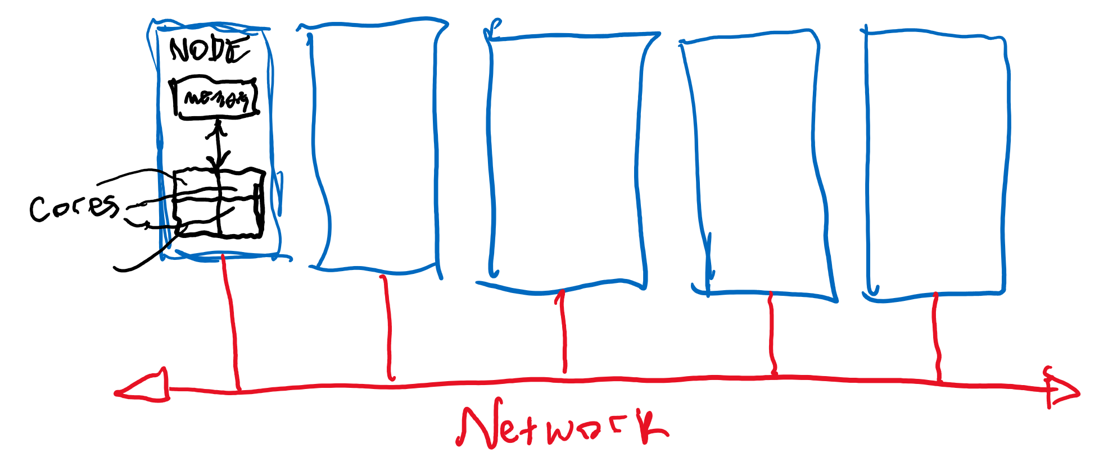
Parallel Computer Cluster
- Each compute node is a multi-processor parallel computer in itself
- Multiple compute nodes are networked together via Infiniband network, Ethernet network, optical fibre, etc…
- Special purpose nodes, also multi-processor
- The majority of the worlds large parallel computers (supercomputers) are clusters of hardware produced by a small handful of (mostly) well known vendors, ie. Lenovo, IBM, Cray Inc., Huawei, Dell EMC, Fujitsu, Nvidia, etc…

Why Parallel Computing
- The real world is massively parallel
- Many complex, interrelated events take place simultaneously, yet within a temporal sequence
- Compared to serial computing, parallel computing is much better suited form modelling, simulating, and understanding complex, real world phenomena
- Eg. Modeling traffic on a highway, Formation of a galaxy, planetary movements, or climate change
- Parallel computing saves time and money
  - In theory, more resources thrown at a task will shorten its time to completion with potential cost savings
  - Parallel computers can actually be built from cheap, commodity components
- Parallel computing also makes better use of underlying parallel hardware
  - Modern computers, laptops, are parallel in architecture w/ multiple processors/cores
  - Parallel s/w is specifically intended for parallel h/w with multiple cores/threads, etc…
  - In most cases, serial programs run on modern computers actually waste potential computing power by not leveraging the benefits of parallel computing
- There was a 50%/year performance increase of microprocessors from 1986 to 2002 (Moore’s Law = # of transistors on a microchip would double every 2 years). After 2002, performance increase slowed down to ~20%/year, marking a dramatic deceleration.
  - 50% = 60 times faster year over year
  - 20% = 6 times faster year over year
- Manufacturers rapidly increased performance but not anymore in monolithic processors, but instead through parallelism -> multiple processors on a single integrated circuit.
  - “An electronic hardware system, such as a multi-core processor, is called "monolithic" if its components are integrated together in a single integrated circuit. Note that such a system may consist of architecturally separate components – in a multi-core system, each core forms a separate component – as long as they are realized on a single die.” – Wikipedia
- Parallel systems marked a required change in software design -> instead of serial programs we now need parallel programs
- To solve larger, more complex problems
  - Many problems are so large and complex that it is impractical or impossible to solve them on a single computer/processing unit, especially given limited memory
  - Eg. Grand challenge problems that require PetaFLOPS and PetaBytes of computing resources to solve
  - Web search engines/databases that require the processing of millions of transactions every second
- To provide concurrency
  - A single compute resource can only do one thing at a time, but multiple compute resources can do many things simultaneously
  - Eg. Collaborative networks provide a global venue where people form around the world can meet and conduct work virtually
- To take advantage of non-local resources
  - Using compute resources on a wide area network (WAN), or even the Internet when local compute resources are scarce or insufficient

Why The Need For ever Increasing Performance?
- The complexity of problems is growing as computational power increases
- Eg. Climate modeling, protein folding, drug discovery, energy research, data analysis

Trends
- Over the last 20+ years, ever faster networks, distributed systems and multi-processor computer architectures (even at the desktop level) clearly show that parallelism is the future of computing
- In this same time period, there has been a greater than 500,000x increase in supercomputer performance with no end currently in sight
- The race is already on a an exascale for computing (exaflop = 10^8 calculations per second)

Parallel Computing Projects
- Science and Engineering - Historically, parallel computing has been the considered the “high end” of computing and has been used to model difficult problems in many areas of science and engineering, such as:
  - Atmosphere, Earth, Environment
  - Physics – applied, nuclear, particle, condensed matter, high pressure, fusion, photonics
  - Bioscience, Biotechnology, Genetics
  - Chemistry, modular sciences
  - Geology, Seismology
  - Mechanical engineering – from prosthetics to spacecraft
  - Electrical engineering, circuit design, microelectronics
  - And more…
- Industrial and commercial – Today, commercial applications provide an equal or greater driving force in the development of faster computers. These applications require the processing of large amounts of data in sophisticated ways. Ie:
  - Big data, databases, data mining
  - Web search engines, web based business services
  - Medical imaging and diagnosis
  - Financial and economic modeling
  - Advanced graphics and virtual reality, particularly in the entertainments industry
  - Networked video and multimedia technologies
  - Artificial intelligence
  - Etc…

Global Applications
- Parallel computing is now being used extensively around the world, in a wide variety of applications

Why the Need to Write Parallel Programs?
- Running multiple instances of the same program
  - Independent processes -> high parallelism
  - However is not the common desired case
- Results in faster running programs
  - Converting it from serial to parallel (to run on multiple cores)
- Automatic serial to parallel translators exist however they have really bad efficiency
  - Translation is complex and inefficient
  - Not straightforward
  - Eg. Converting the multiplication of n x n matrices
    - Originally -> sequence of dot products
    - Parallel -> sequence of parallel dot products
      - This is very slow on many systems due to inefficient parallelization -> not finding the efficient parallelization of each step, but stepping back and devising a totally new algorithm
  - Thus parallel programs must be specifically designed and written rather than translated from existing serial solutions

How to Write Parallel Programs
- There are many possible ways to translate parallel programs, all of which share the same basic concept of partitioning
- Two approaches:
  - Task parallelism
    - Partition the problem into several tasks assigned to many cores
  - Data parallelism
    - Splitting data across many cores -> cores will execute same/similar tasks but the input data is split amongst them
  - Eg. Course w/ 120 students, 4 TA’s: ‘A’, ’B’, ‘C’, and ‘D’, and a final with 5 questions.
    - The prof and TA’s are essentially cores, grading a question is a task, and the student’s answers is the data
    - Task parallelism = Prof + TA’s grade one question on each exam -> grade 120 exams each
      - May be unbalanced as questions are not guaranteed to be equal/similar in difficulty to grade
    - Data parallelism = 120 exams split into 5 piles, Prof + TA’s grade 24 exams each in full

Parallelism Complexity
- For independent operations/tasks, parallel design is as simple as sequential
- For coordinated work, there is a higher complexity

What Will Be Done In This Course
- Build programs through explicit parallelism
- C language for example
  - Message passing interface (MPI)
  - POSIX threads -> pthreads / C++11 threads
  - OpenMP
- Different languages/extensions -> different parallel systems
  - Two major parallel systems:
    - Shared memory system
    - Distributed memory system

Concurrent, Parallel, and Distributed
- Concurrent computing = multiple tasks might be in progress at any instant
- Parallel computing = a program w/ multiple tasks closely cooperating to solve a problem
- Distributed computing = a program cooperating w/ other programs to solve a problem
- There isn’t complete agreement on the distinctions between these terms
- Blurry distinction in parallel vs distributed
  - Coupling -> distributed is more loosely coupled
  - Memory -> shared memory programs are parallel

Von Neumann Architecture
- Named after the Hungarian mathematician/genius John von Neumann
  - First authored the general requirements for an electronic computer in his 1945 papers
- Also known as the stored program computer
  - Both program instructions and data are kept in electronic memory
  - Differs from earlier computers which were programmed through “hard wiring”
- Is the “classic” computer architecture
- Components:
  - Main memory
  - Central processing unit (CPU) -> processor, core
    - Control unit and Arithmetic Logic Unit (ALU)
    - Registers, program counter
  - Interconnection -> CPU and memory
    - Bus -> parallel wires (von Neumann bottleneck)
- Execution -> one instruction at a time
  - Fetching or reading from and writing or storing into memory
- Since the inception of von Neumann architecture, virtually all computers have followed this basic design
  - Four main components:
    - Memory
    - Control Unit
    - Arithmetic Logic Unit
    - Input/Output
  - Read/write, random access memory is used to store both program instructions and data
    - Program instructions are coded data which tell the computer what to do something
    - Data is simply information to be used by the program
  - Control unit fetches instructions/data from memory, decodes the instructions and then sequentially coordinates operations to accomplish the programmed task.
  - Arithmetic Logic Unit performs basic arithmetic operations
  - Input/Output is the interface to the human operator
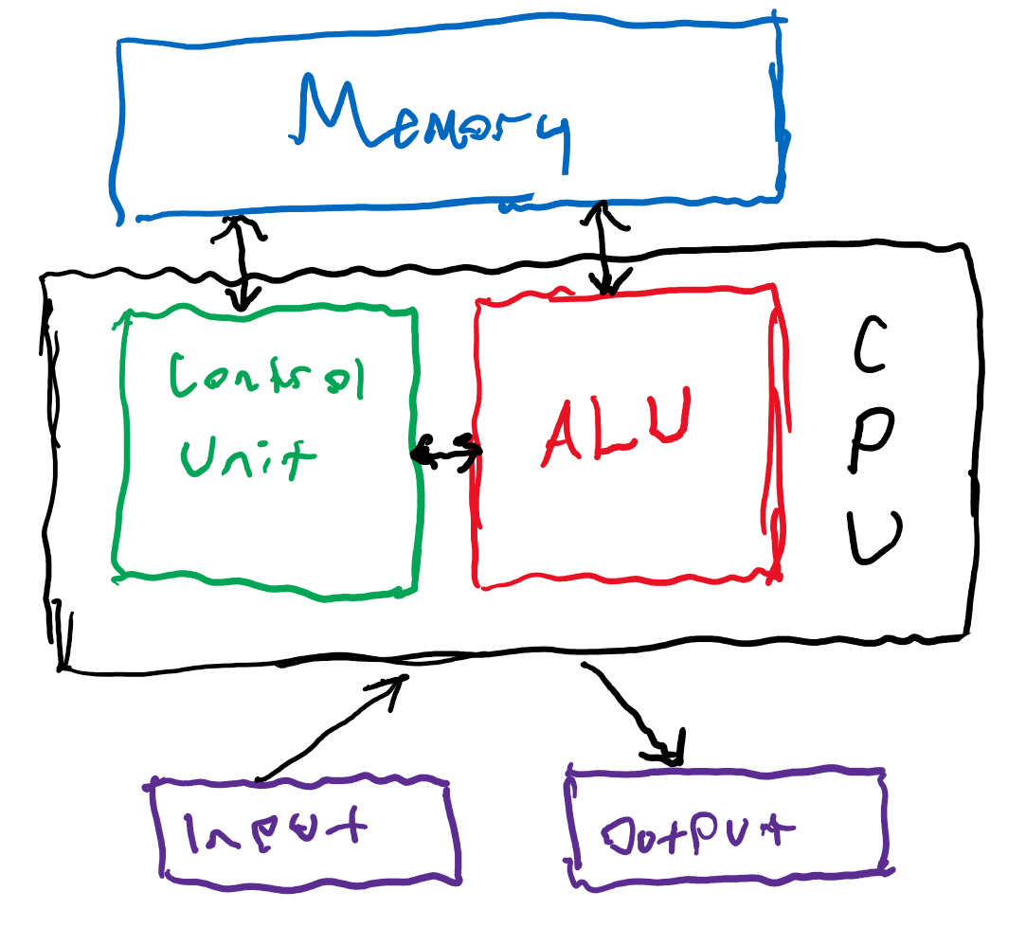
- Why is this architecture important? Parallel computers still follow this basic design, just multiplied in units. The basic fundamental architecture stays the same

Processes, Multitasking and Threads
- Process = an instance of a computer program
  - Consumes a block of memory containing:
    - Executable code
    - Call stack -> storing all active functions
    - Heap -> memory locations
    - IO descriptors
    - Security data
    - Execution state
- Multitasking = multiprogramming and time slicing (time sharing)
  - Maximizing CPU utilization (blocking calls) and fairness
- Threading = splitting programs into smaller parts and running them concurrently
  - A light weight process
  - Thread -> forks off the parent process or joining the process

Modifications to the Von Neumann Architecture
- Addressing performance issues such as the von Neumann bottleneck
  - Von Neumann Bottleneck = the idea that a computer system’s throughput is limited due to the relative ability of processors compared to the top rates of data transfer. According to this description of computer architecture, a processor is idle for a certain period of time while memory is accessed. The von Neumann Bottleneck thus looks at how to serve a faster CPU by allowing faster memory access.
- Caching -> leverage the principle of locality
  - Faster access = CPU cache (on same or separate chip)
  - Of limited size (smaller) for easier management
    - Keeping it consistent and fresh
      - Policies -> LRU
  - Locality (spatial and temporal) -> example:
Float z[1000];
. . .
Sum = 0.0;
For (i=0; i < 1000; i++)
Sum += z[i];
- .
  - Levels: L1, L2
  - Fetching -> cache hit, cache miss
  - Inconsistency -> write through or write back (dirty entries)

Cache Mapping
- Where to store cache lines/blocks
- A variety of strategies -> spectrum
  - Fully associative -> any location in cache
  - Direct mapped -> unique location in cache for the line

